Landing, Login, and Enrollment Pages Development

Selina Rodriguez

CST499: Capstone for Computer Software Technology

Instructor: Amr Elchouemi

January 25, 2021

Explain how to run a PHP file in XAMPP.

In order run a PHP file in XAMPP a code needs to be generated it can be saved on notepad a home.php or any name as long as it ends in .php. After the code has been generated you must go the XAMPP control panel and select start next to Apache and MySQL. Once you have selected start your servers you can run the code but you must first make sure the code is saved to C:/Program Files/XAMPP/htdocs A folder would need to be created in htdocs and you can name the folder as project now you can save your file in the new folder created in htdocs. You will then now run your code and open up the browser and type in localhost/project/home.php. Your code should be generated on the screen now.

Create the landing page, login page, and registration page for new users.

Landing Page



Registration Page

Create the MySQL database and tables.

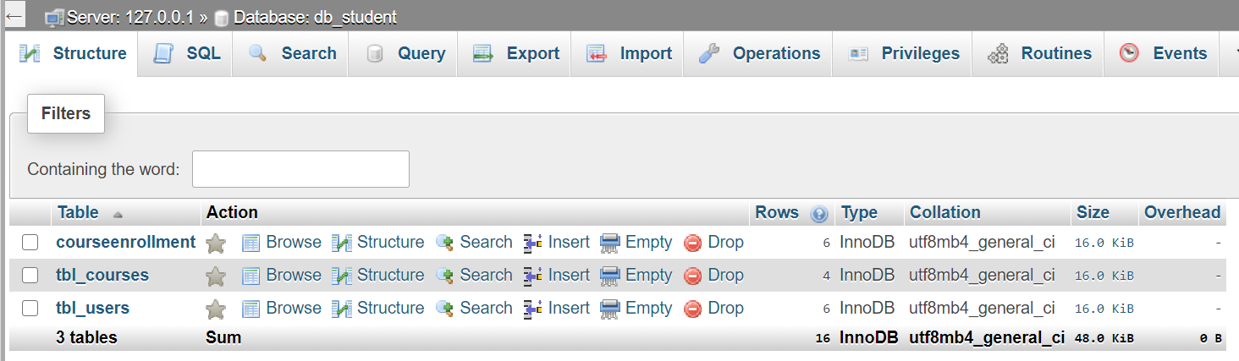

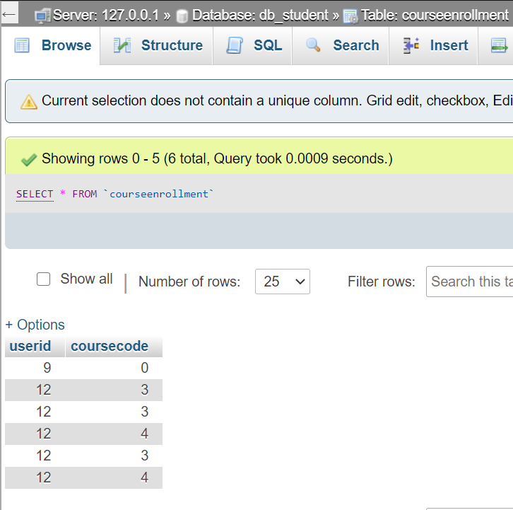

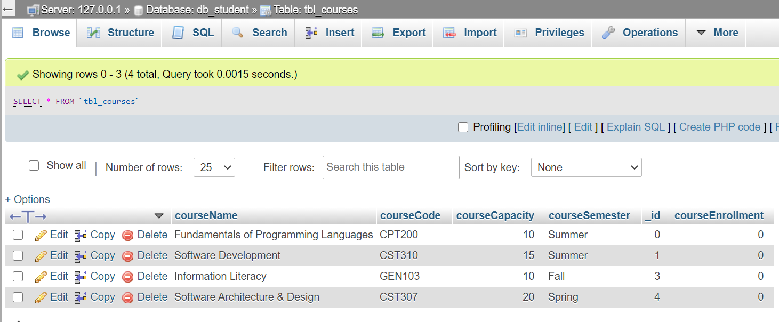

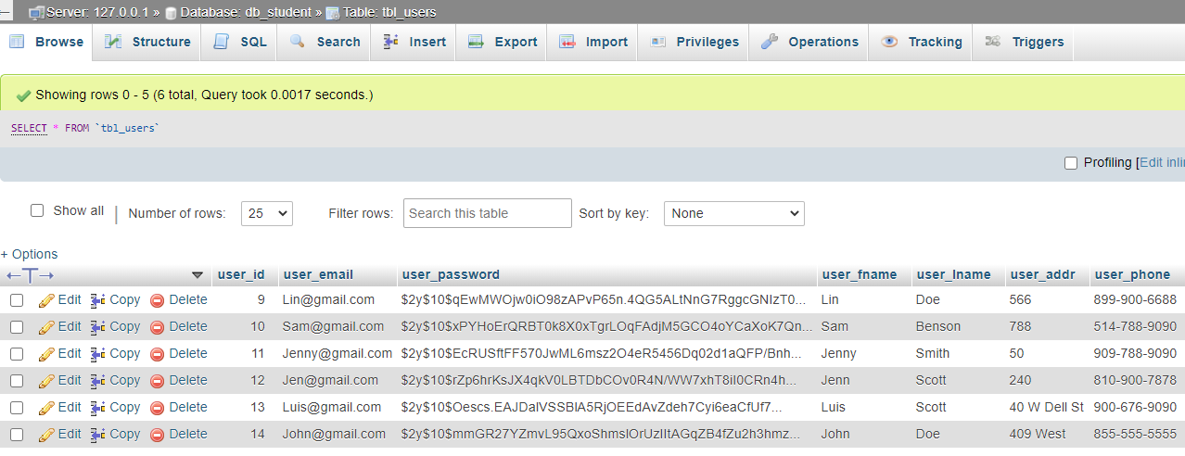

Discuss the MySQL database functions that you used and the steps you took to create the

database connection custom class.

I used the function on MySQL to create the tables and rows. For the student registration I set it up as the following ID, firstname, lastname, email, phonenumber, password. For the ID I made sure that auto increment was selected to generate ID for each time a user is added to the database.

Develop the registration page layout.

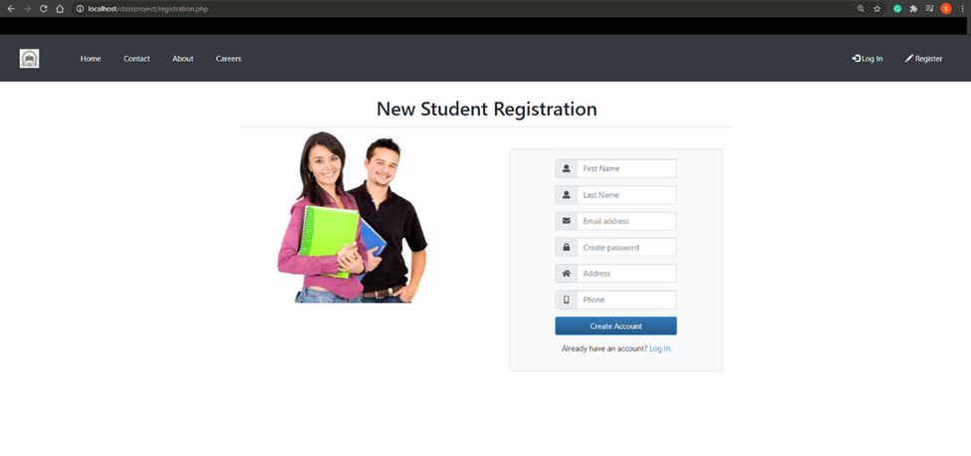

Develop the registration page PHP source code.



Develop the table that saves the user information in the database.

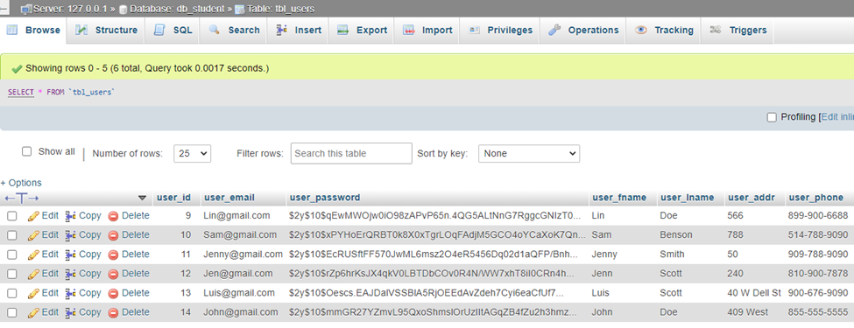

Explain the steps taken to create the registration page and save the user information in the database.

Connected the registration page to the database by inserting values that were inserted in the page to be inserted into tbl_users.